Chapter 11, Solution 67.

For the op amp shown in Fig. 11.86, calculate:

(a) the complex power delivered by the voltage source
(b) the average power dissipated by the 12-Ω resistor

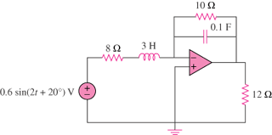

Figure 11.86
For Prob. 11.67.

Solution
The frequency-domain version of the circuit is shown below.
Z₂=2-j4

Z₁ =8+j6 I₁
-
+ I_{o}
+ +
V V_{o}
-
-

(a)

S = (14.4+j10.8) mVA = 18∠36.86° mVA

(b)

P = 2.904 mW

(a) 18∠36.86° mVA, (b) 2.904 mW

